Project Design Phase-II
Technology Stack (Architecture & Stack)

Date | 30 August 2026
Project Name | Automated Network Request Management
Maximum Marks | 4 Marks

Technical Architecture:
The Automated Network Request Management system is designed as a multi-layer architecture that allows employees to submit and track network requests such as New Network Connection and Network Relocation. The system automates request validation, approval, task assignment, notifications, and status tracking.

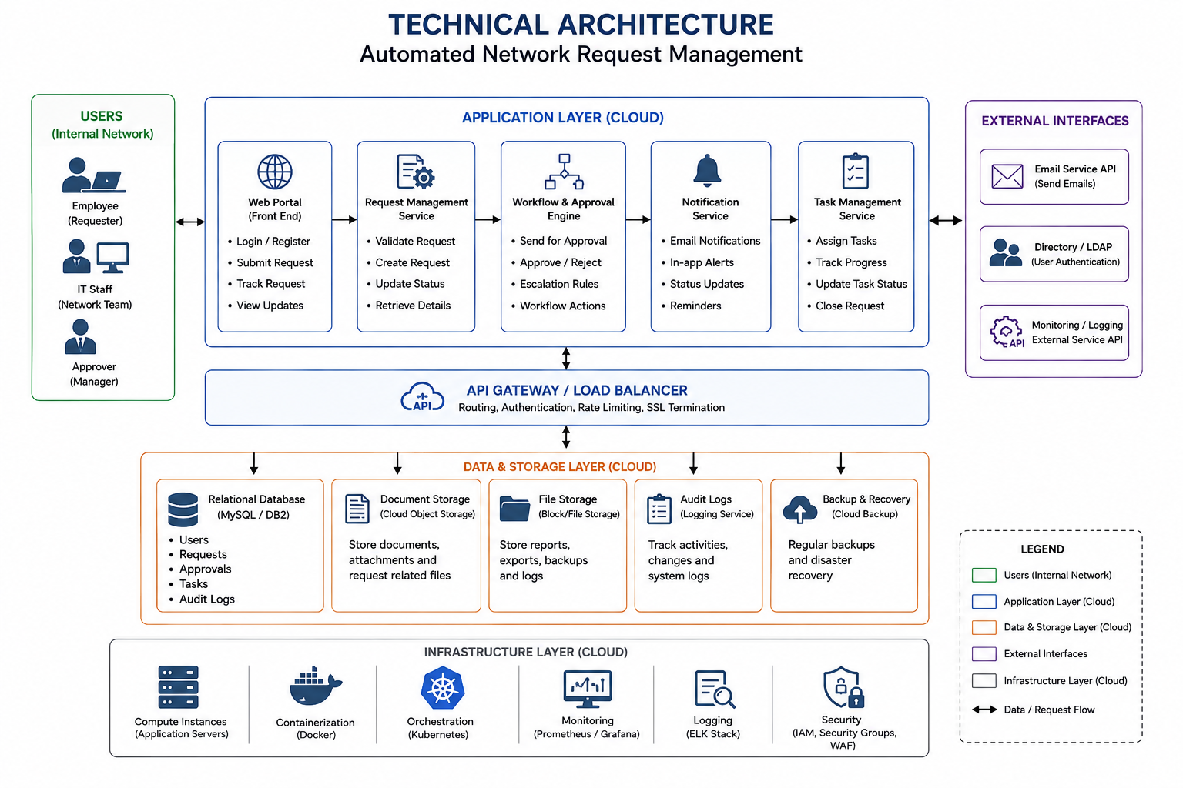
Employee / Requester ↓
↓ Request Processing
Service Catalog ↓
↓ Status Update
Network Request Form ↓
↓ Email Notification
Client Scripts / UI Policies ↓
↓ Request Completed
Network Request Record
↓
Approval
↓
Flow Designer
↓
Network Support Team

Main Components
- User Interface – Service Portal for employees to submit and track requests.
- Request Management – Validates and manages network requests.
- Workflow & Approval – Automates approval and rejection processes.
- Task Management – Assigns approved requests to the network/IT team.
- Notification Service – Sends email and status notifications.
- Database – Stores users, requests, approvals, tasks, and request status.
- Authentication & Access Control – Provides secure user login and role-based access.
- Monitoring & Logging – Tracks system activities and errors.
- Backup & Recovery – Protects request data and supports data recovery.
- Cloud Infrastructure – Hosts and runs the application services.

